Advanced Software Engineering

Lab9

Krishna Kanth Ganguri

Class id - 21

Mixin Pattern for Register

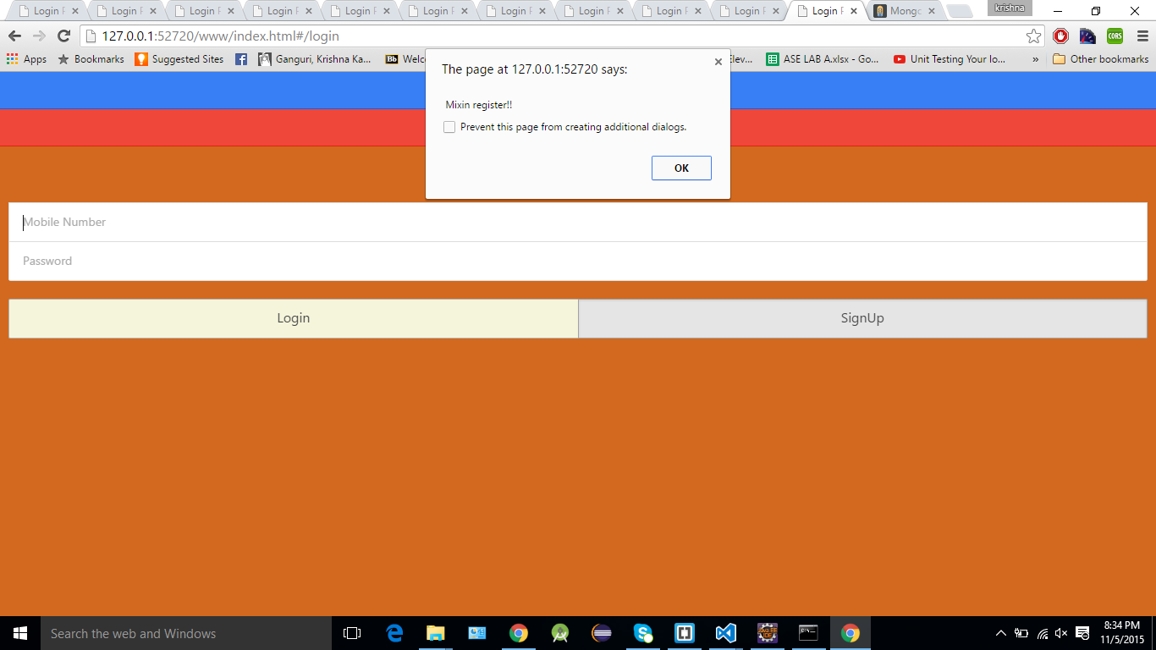

Mixin Pattern for Login

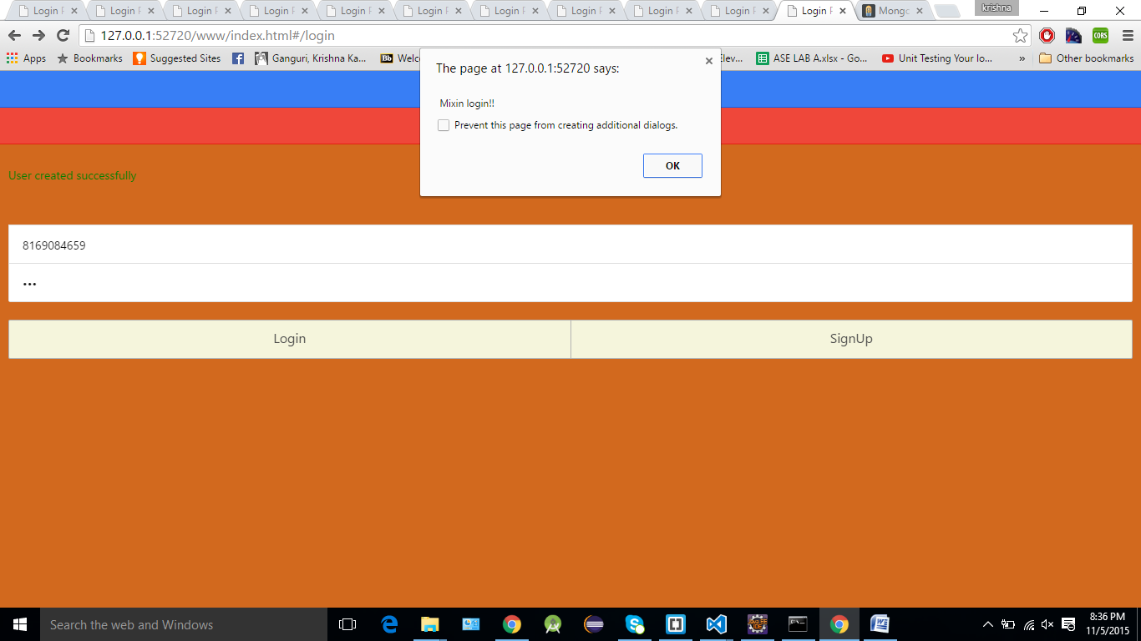

Mixin Pattern for Regsiter

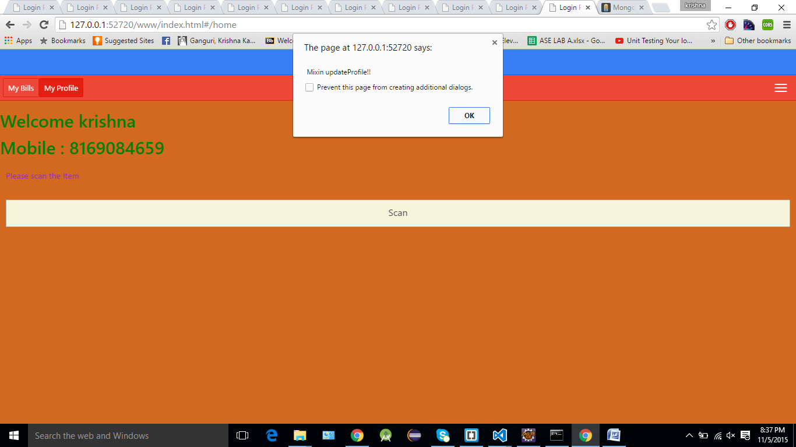

Code for Mixin pattern

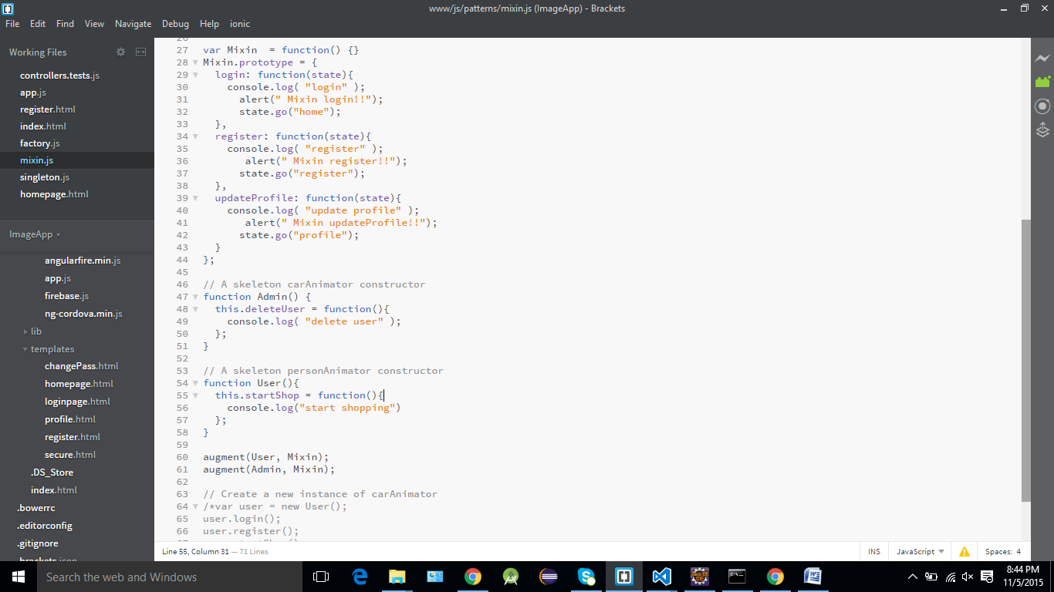

Singleton Pattern is used to login into application

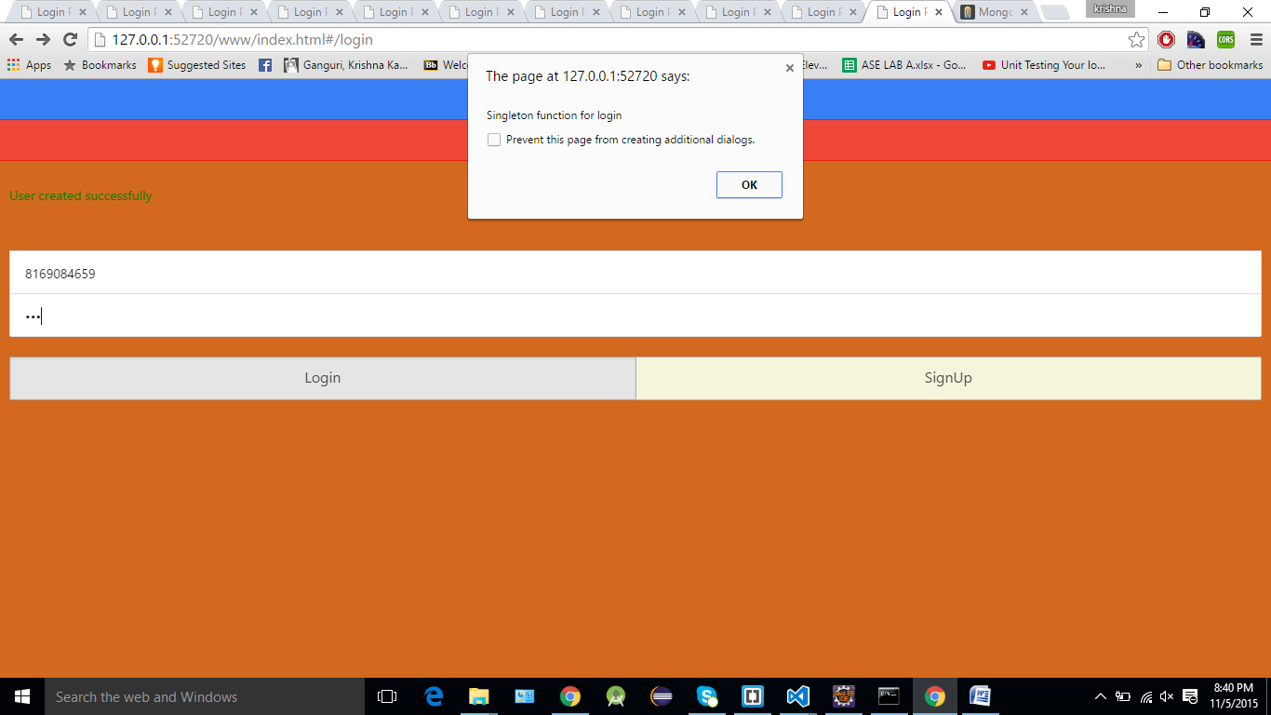

Code for Singleton Pattern

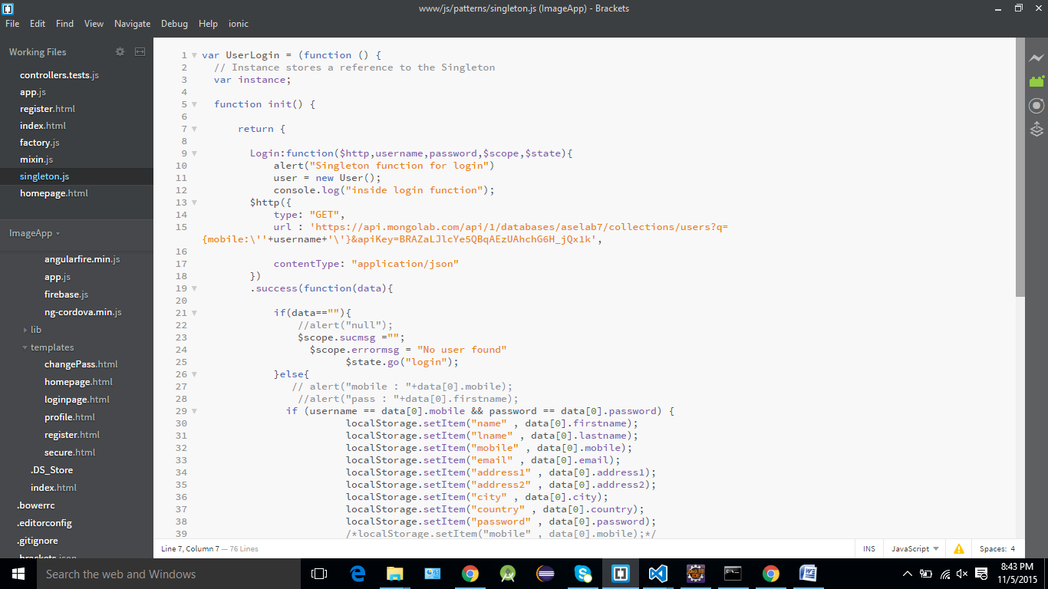

Factory pattern is used to display user details

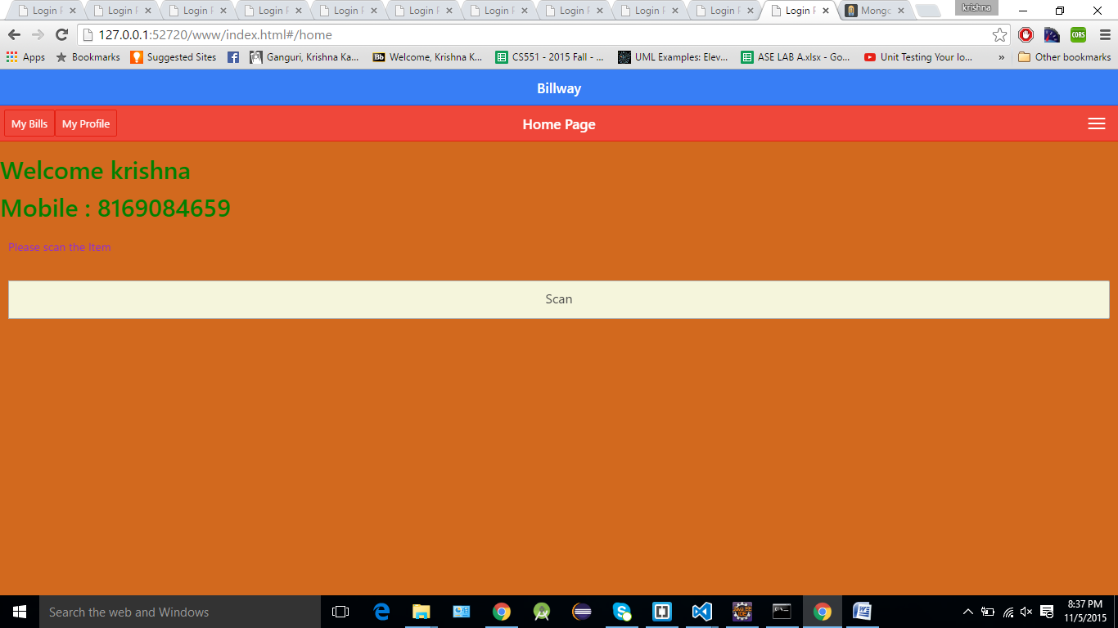

Code for factory pattern

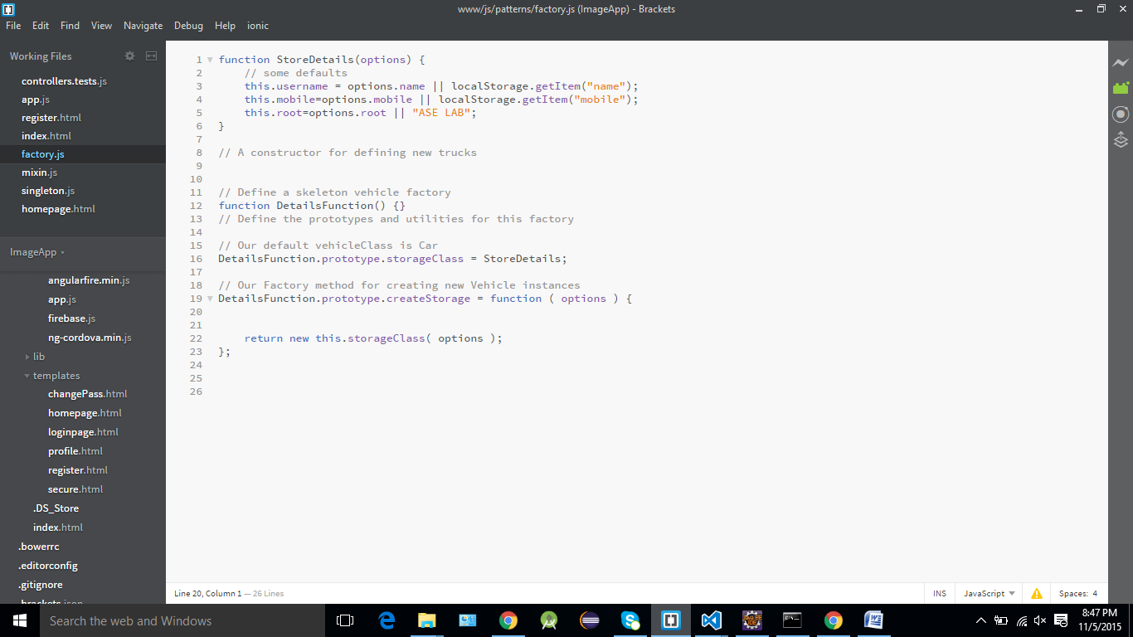

Application is deployed in Bluemix

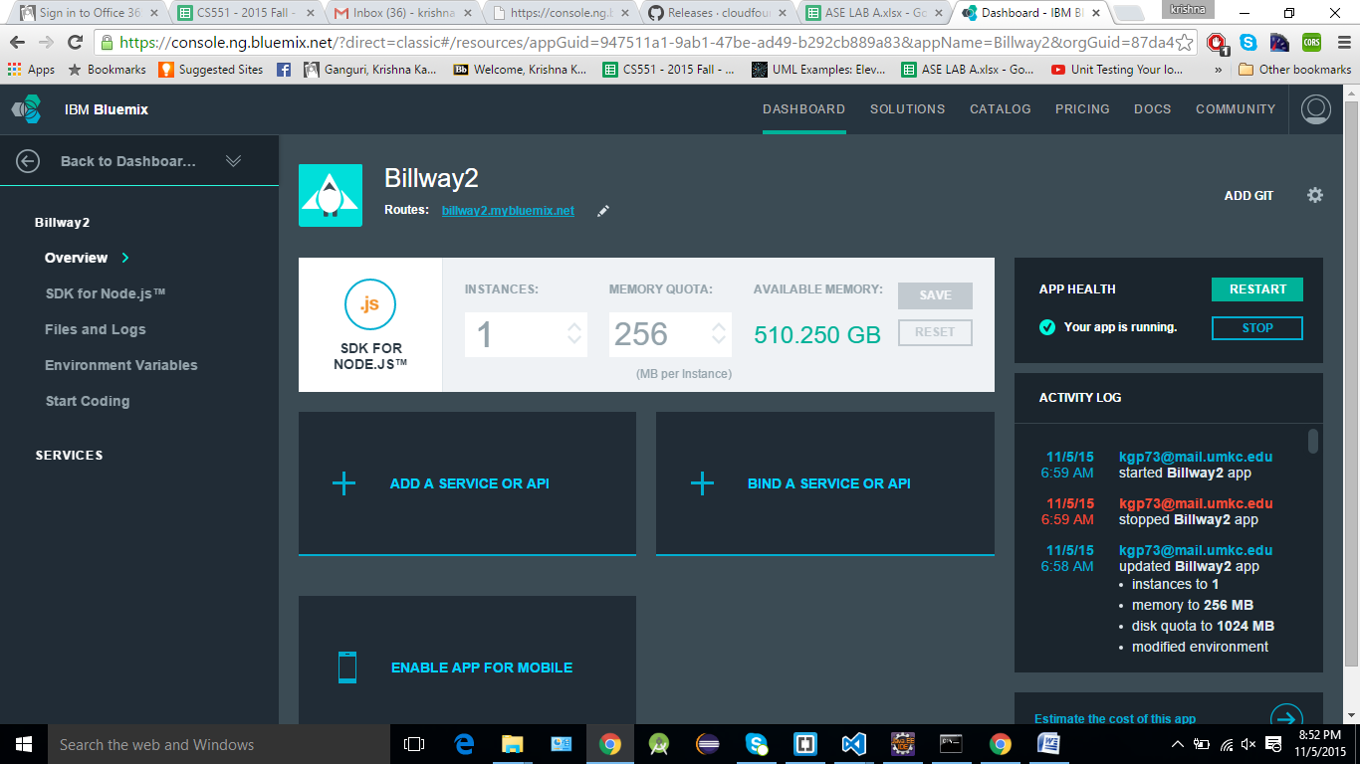

Application in bluemix

